The pie chart below shows the contribution to the economy of Turkey
by sector in 2000 and 2015.

Summarize the information by selectin and reporting the main features, and make comparison where relevant.
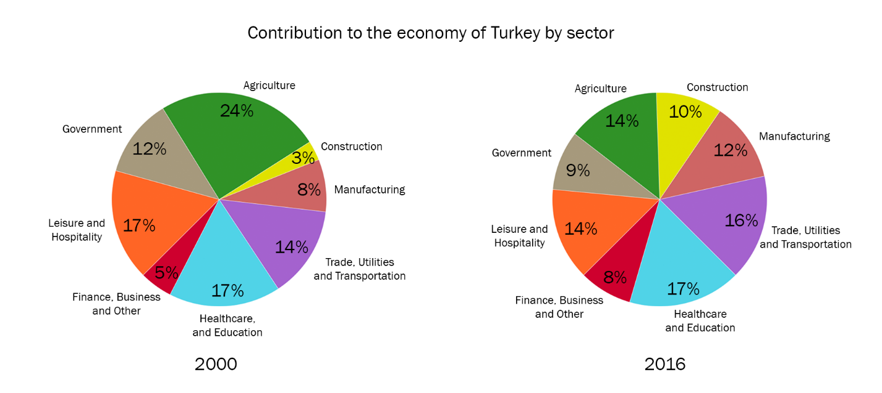

PIE CHARTS

• Use the information regarding graphs to describe trends.
• Show that you are looking at the pie chart: From the pie chart, it is clear/obvious/
evident that ...
• Relate a particular item in the pie chart to an aspect of the graph/chart: ... is related/ connected to/has an effect on/affects ... , because ...
• You can compare/contrast items: ... while ... ; in contrast, ...
• You can use the pie chart to help you draw conclusions about the graph: The pie chart suggests that ... and show the relationship between the two.
• Use language to compare and contrast further, showing as many links as possible.
• Always link data from different sources to each other.

